

MANIPAL SCHOOL OF INFORMATION SCIENCES
(A Constituent unit of MAHE, Manipal)

CYE 5103 Linux OS and Scripting – 2 Theory

Reg. Number | Name | Branch
261100690010 | Hegde Aansh Dilip | Cyber Security

22/08/2026


Compare Permissions on Regular Files and Directories
Create a regular file named sample.txt and a directory named sample_dir. Create at least one file inside sample_dir.
Apply each of the following permissions using chmod. Perform the specified operations and record your observations.
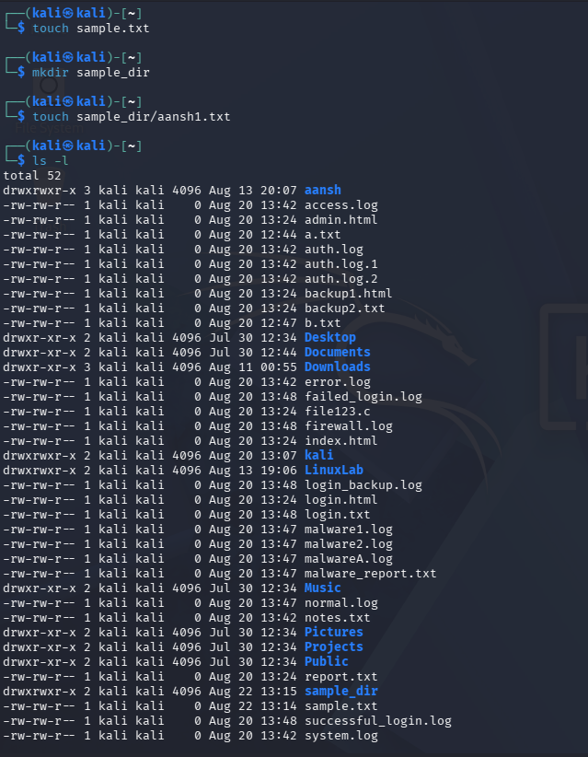
1. Setting up:

2. 400(r---)
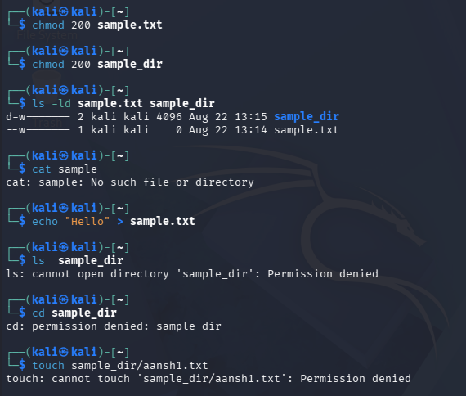

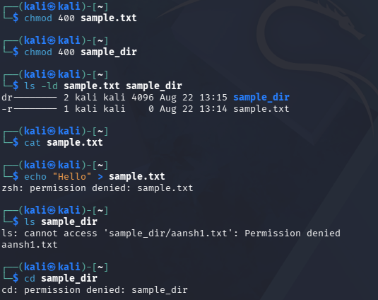
3. 200(-w-)

4. 100(--x)
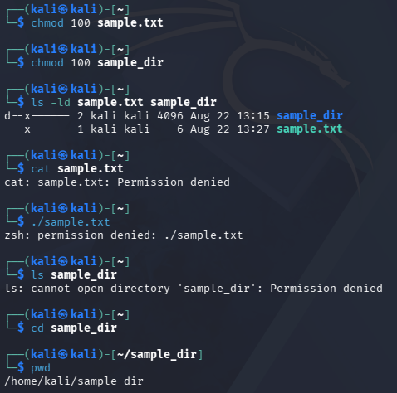

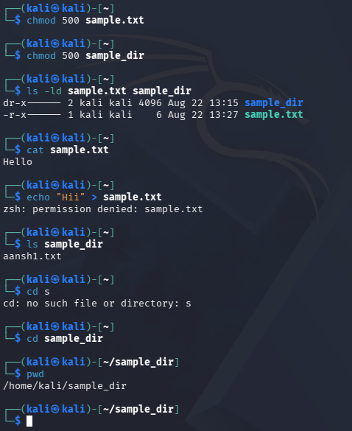
5. 500(r-w)

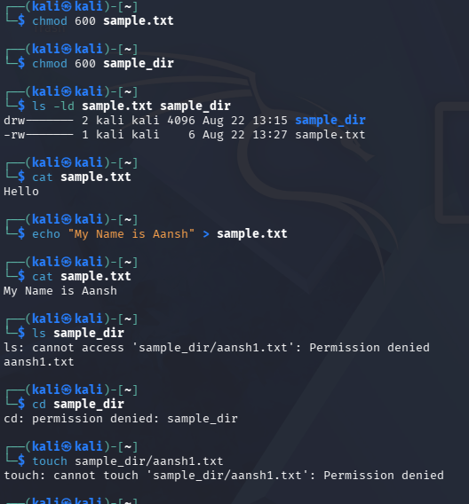
6. 600(rw-)

7. 700(rwx)
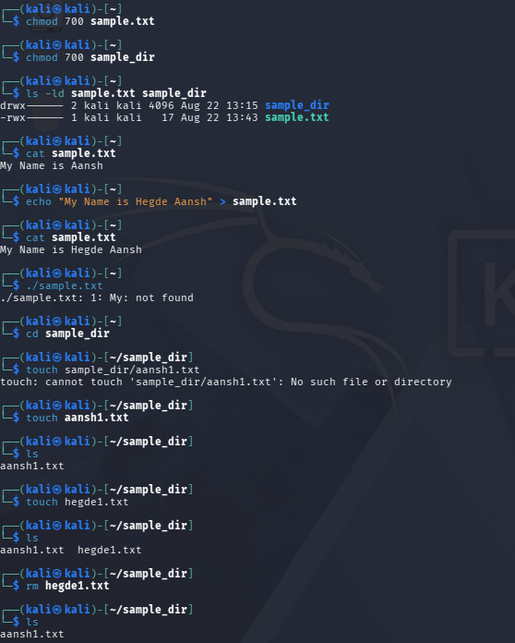

Permission | Regular File (sample.txt) – Test | Observation | Directory (sample_dir) – Test | Observation
400(r--) | Try to read and modify the file | Will be able to read successfully but can’t modify it(permission denied) | Try to list and enter the directory | Will list the filename but can’t access it and cannot enter the directory
200(-w-) | Try to read and modify the file | We cannot read the file but can modify it | Try to list, enter,create a file | Cannot list,enter or create a file
100(--x) | Try to read and execute the file | Cannot read or execute the file | Try to list and enter the directory | Cannot list the directory but we can enter it.
500(r-x) | Try to read and modify the file | Will be able to read the file but cannot modify it | Try to list and enter the directory | Can list and enter the directory
600(rw-) | Try to read and modify the file | Can both read and modify the file | Try to list,enter and create a file | Can list filename but cannot enter directory or create files
700(rwx) | Try to read, modify and execute the file | Will be able to read, modify and execute the file | Try to list,enter , create and delete files | Will be able to list,enter, create and delete files

Question:
- What does read (r) permission allow you to do with a regular file?
It allows you to read and view the contents of the file.
- What does read (r) permission allow you to do with a directory?
It allows you to list the names of files and directories inside the directory.
- What does write (w) permission mean for a regular file?
It allows you to modify, overwrite, or change the contents of the file.
- What does write (w) permission mean for a directory?
It allows you to create, delete, and rename files or directories inside it, usually when combined with execute (x) permission.
- What does execute (x) permission mean for a regular file?
It allows you to execute the file as a program or script, if it is a valid executable.
- Why is execute (x) permission important for accessing a directory?
It allows you to enter and traverse the directory and access its contents.
- Which permission combination allows the owner to fully access a regular file?
700 (rwx) — the owner can read, write, and execute the file.
- Which permission combination allows the owner to fully access a directory?
700 (rwx) — the owner can list, enter, create, delete, and manage files in the directory.
- Why do the same r, w, and x permissions behave differently for a regular file and a directory?
The permissions apply to different types of objects. For a regular file, r means reading contents, w means modifying contents, and x means executing the file. For a directory, r means listing its contents, w means creating/deleting/renaming entries, and x means entering or traversing the directory.

